1. **Introduction**

Charitoo Cuisine is a restaurant and catering service that offers customers a unique experience through tasty food, friendly and accommodating services in an affordable price, and a hearty welcome. Charitoo Cuisine's mission is to deliver the best possible food, service, people, and profit while delivering exceptional guest and employee care via a common commitment to excellence. Being among the finest in their field, they constantly strive to surpass their own accomplishments.

The restaurant was established during the time of pandemic by Mrs. Jesan Masing, the owner of the Cuisine. The main reason Mrs. Masing establish this kind of business is because of need in which they have no other source of income during the lockdown. Mrs. Masing shared that they have a small restaurant way back 2014 but unfortunately, it was destroyed due to the fire accident.

Charitoo Cuisine is located in Barangay San Jose, Sogod, Southern Leyte. The target market of this restaurant are the professionals specially, those who work in LGU’s, private and public companies, online customers and nearby people or neighbors. The restaurant offers three categories of foods: food for breakfast, Lunch, and Dinner which consist of typical Filipino Dishes. While, for the Catering service the common or minimum range of order for main dishes are not less than three and one side dish.

**Vision**

“We are committed to providing the highest caliber of cuisine, service, people, and profit while providing outstanding care for our guests and employees via a shared dedication to excellence. As one of the best in our sector, we always aim to go above and beyond our own achievements.”

**Mission**

To provide our clients with a distinctive experience by providing delicious food, amiable, responsive service, a competitive pricing, and a warm greeting.

**Objectives**

The purpose of this paper entitled “Charitoo Cuisine Restaurant; A Risk Management Plan” are the following;

1. Identify potential risk associated with the restaurant operation
2. Assess the probability and impact of each identified risk
3. Implement effective strategies to mitigate and manage risk

**Risk Management Team**

Business Manager: Mrs. Jesan Masing

Head Chef: Mrs. Jesan Masing

Mr. Emilito Ohayo

Front-of-house Manager: Mrs. Gemema Engaston

Mrs. Romema Martinez

Risk Manager: Mr. Leslie Masing

**Assessing Potential Risk**

The following are the risk analysis to quantifying and communicating the level of impact and likelihood then prioritize significant risk associated with each identified risk in Charitoo Cuisine Restaurant.

**Likelihood**

|  |  |  |
| --- | --- | --- |
| **Level** | **Descriptor** | **Description** |
| A | Frequent | Indicates a high probability of risk to occur |
| B | Likely | Moderate to high probability of risk to occur |
| C | Possible | Implies a moderate probability of risk to occur |
| D | Unlikely | Indicates a low to moderate probability of risk to occur |
| E | Rare | Low probability of risk to occur |
| F | Never | Risk is not foreseable to occur |

**Consequence**

|  |  |  |
| --- | --- | --- |
| **Level** | **Descriptor** | **Description** |
| 1 | Insignificant | Minimal impact, manageable consequences |
| 2 | Minor | Limited impact, with manageable consequences requiring some resources |
| 3 | Major | Substantial impact, potentially causing significatnt disruption or resource allocation |
| 4 | Critical | Severe impact, with the potential for severe consequences that could jeopardize project success |
| 5 | Catastrophic | Extreme impact, with consequences that could be irrecoverable or have severe long-term |

**Likelihood and Consequence**

|  |  |  |  |  |  |
| --- | --- | --- | --- | --- | --- |
| **Likelihood** | **Consequence** | | | | |
|  | **1** | **2** | **3** | **4** | **5** |
| A | S | S | H | H | H |
| B | M | S | S | H | H |
| C | L | M | S | H | H |
| D | L | L | M | S | H |
| E | L | L | M | S | S |

*Legend:*

**H** High risk; Requires Immediate attention and action at senior levels

**S** Significant Risk; senior management attention needed

**M** Moderate Risk; Manage with regular monitoring and mitigation

**L** Low Risk; Generally acceptable; Monitor periodically

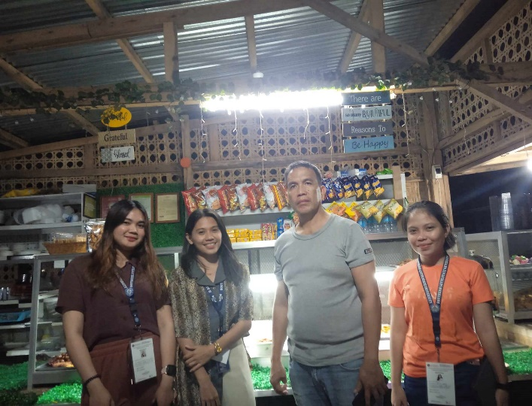**Documentation**

